**Design and Development of a System for Accident Prevention Caused by Driver’s Drowsiness**

Subham Saha, Debojyoti Dey, Shramona Chakraborty, Abhishek Sarkar*, Soma Bandyopadhyay, S.S. Thakur

Department of Computer Science and Engineering

* Department of Electronics and Communication Engineering

MCKV Institute of Engineering, Liluah – 711204, INDIA

[subhamsaha90@gmail.com, 033debo033@gmail.com, chakrabortyshramona@gmail.com](mailto:subhamsaha90@gmail.com, 033debo033@gmail.com, chakrabortyshramona@gmail.com), [abhisheksarkar30@gmail.com](mailto:abhisheksarkar30@gmail.com), [somabanmukh@yahoo.co.in](mailto:somabanmukh@yahoo.co.in), subroto_thakur@yahoo.com

**ABSTRACT**

Road accidents have earned India a dubious distinction. With over 130,000 deaths annually, the country has overtaken China and now has the worst road traffic accident rate worldwide. Every hour, 40 people under the age of 25 die in road accidents around the globe. According to the WHO, this is the second most important cause of death for 5 to 29 year olds. Now the major cause of this problem is driver fatigue and carelessness. So we decided to analyse the trends and found out that the one of the major reasons of accident is long haul drives where the driver might fall asleep. So we have proposed a system which would prevent accident due to this reason.

Keywords: Drowsiness, Arduino, Touch Sensor, Accelerometer, Accident Prevention.

1. **Introduction**

National Highway Traffic Safety Administration (NHTSA) analysis data indicates that drowsiness while driving is a contributing factor for road accidents and it results in 4-6 times higher crash risk relative to alert drivers [1]. Most of the fatal road accidents occur at speeds greater than 70 Kmph. The World Health organization (WHO) has reported that India has the worst road conditions in the world resulting approximately two and a half lakh deaths in 2010 and 2011 [2].

Research shows that driver fatigue and drowsiness is one of the major reasons for the increasing accidents [3].Driver fatigue not only impacts the alertness and response time of the driver but it also enhances the chances of being involved in car accidents. The sleepy drivers fail to take right actions prior to a collision. An important irony in driver’s fatigue is that the driver may be too drained to comprehend his own level of drowsiness. This significant problem is often ignored by the driver.

1. **Related Work**

A lot of research work have been done in recent years on systems for driver inattention detection, focused mainly in drowsiness, with a broad range of techniques. Sleep has a long history of research in the fields of psychology and medicine, where accurate measurements and indicators have been developed [3].

1. ***Physiological Measure***

A set of physiological parameters has been defined for determining stress are Electrocardiogram, Electroencephalography, Electromyogram, skin conductance, respiration etc. One of the most prominently method is the Electro encephalography (EEG), the electrical activity of the brain. Experiments which have been done earlier by different researchers taking different parameters like Electro-Oculogram (EOG), EEG, ECG, Electromyogram (EMG) and skin conductance. It has been established that the variations in the Heart Rate can detect different physical conditions including drowsiness.

Electroencephalograms (EEG) [4] represent the electrical changes in the brain, measured with a series of electrodes placed in the scalp. The electrodes detect small voltages produced in the brain cortex. These potentials form waves at several frequencies, known as delta, theta, alpha, beta and gamma waves, which are linked to different cognitive and motor processes, including drowsiness and the different sleep stages. Brain studies couple EEG with electrooculography (EOG), which detects eye movements, and electromyogram (EMG) that monitors muscular tone.

There are various problem related to these techniques is that they are specific to the subject. A lot of wiring is involved which is problem for this approach. The electrode contacts and wires will annoy the drivers, and are difficult to be implemented on vehicles. They require electrodes and other sensors to be placed on the head, face and chest which may annoy the driver. They also need to be carefully placed: installing the electrodes to obtain an EEG requires external help and takes a few minutes, and medical equipment is always expensive.

1. ***Behavioral Measure***

In order to detect drowsiness, studies on driver’s performance use lane tracking, distance between driver’s vehicle and the vehicle in front of it; place sensors on components of the vehicle such as steering wheel, gas pedal and analysis the data taken by these sensors.

1. ***Visual Measure***

A lot of research has been done to detect the visual facial feature changes associated with fatigue. These facial features include eyes, head position, face, or mouth. People in fatigue exhibit certain visual behaviors that are easily observable from changes in facial features like the eyes, head, and face. Visual behaviors that typically reflect a person’s level of fatigue include eyelid movement, head movement, gaze, and facial expression.

1. **Objectives**

The main objective is to first design a system to detect driver’s drowsiness based on his driving pattern using indigenously designed touch sensor which would be placed on the steering wheel and on the gear box. Secondly, to alert the driver on detection of drowsiness by using beep or buzzer.

1. **Proposed Work**

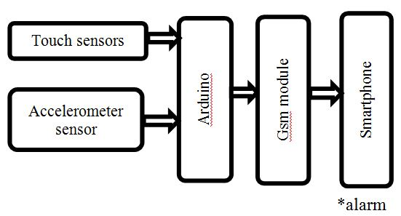The proposed work is based on the behavioral measures. In all the above mentioned methods i.e. behavioral measuring or visual based approach different gestures of driver like eye blink, head movement and yawning are monitored to examine the state of the driver. The aim of this work is to determine whether or not the driver has his hands placed upon the steering wheel and gear box while the car is in motion. It takes into account that while driving a car, a driver should have his hands placed on the steering wheel and also on the gear box. If not on both at least on the steering wheel. The system also takes into account that whether or not the orientation of the steering wheel is held constant for a calibrated period of time. If it happens the system considers that the driver might not be paying attention on the road and thus alerts the driver to do so. The following flowchart would further help to enhance the concept mentioned above.

Fig 1. Block Diagram of the proposed system

1. ***Hardware***

**Arduino** – the microcontroller used to interface the sensors i.e. the touch sensor, the accelerometer sensor. These various sensors takes in the values which is then passed on to the Arduino which processes on it. The output of the Arduino is passed on to the smart phone through the GSM module, i.e. if an alarm is needed to be raised it is passed on to the driver’s smartphone.

**Touch Sensor** – in the transistor current flows from Emitter to Collector. When a 0.3V is applied at the base a biasing voltage is set-up that helps to overcome the threshold barrier. This principle has been applied in our system, where our hands provide the 0.3V voltage required for the same.

**Accelerometer Sensor** – a ADXL335 accelerometer sensor has been used for the system. It helps to determine the orientation of the steering wheel. If the orientation of the steering wheel has not altered for quite some time when the car is in motion, there might be a possibility that the driver is not paying attention on the road or he might be asleep. Which would raise an alarm through the output of the Arduino.

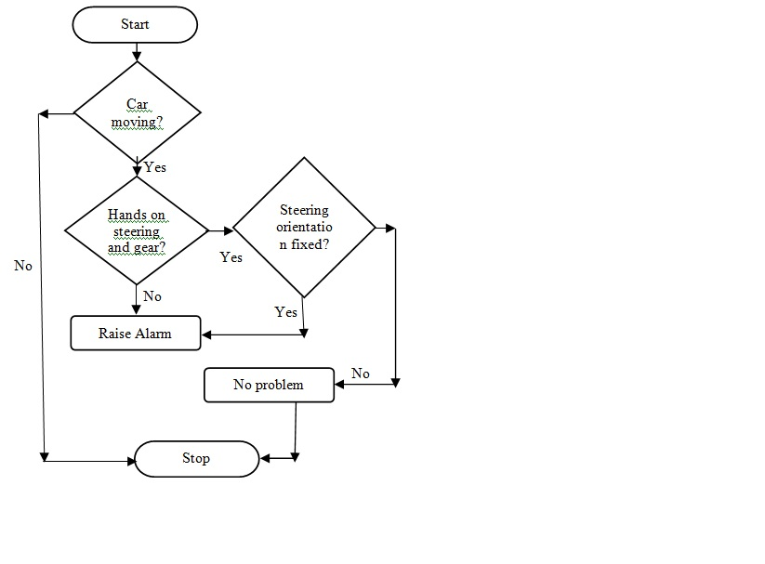**GSM module** – a GSM module is being used to transfer the output signal from the Arduino to the smartphone.

Fig 2. Flowchart of the proposed system

1. **CONCLUSION**

The advantage of the proposed system over the existing system is

1. Cheap to implement and use, thus can be easily integrated into any type of vehicles.
2. Minimizes the error that rises from face detection on rough weather conditions.
3. Accidents due to drowsiness can be avoided.
4. Intelligent and Safe Transportation.

**References**

[1] International Technology Roadmap for Semiconductors, (2001). Semiconductor Industry Association, 2001, Interconnects section, p. 4

[2] R.Ho, K.W.Mai, and M.A.Horowitz, “The future of wires,” Proc. IEEE, vol. 89, no 4, 2001, pp. 490-504.

[3] H.B. Bakoglu, and J.D. Meindl, “Optimal interconnection circuits for VLSI,” IEEE Trans. Electron Devices ED-32 (5), 1985, pp. 903–909.

[4] C.J. Alpert, A. Devgan, J.P. Fishburn, and S.T. Quay, “Interconnect synthesis without wire tapering, ” IEEE Trans. Computer-Aided Design Integrated Circuits and Systems 20 (1), 2001, pp. 90–104.